 | IQVIATM Work Instruction Global Regulatory Affairs -  Regulatory Submissions - Post Approval Changes to Registered Details including CMC,  Administrative and Safety Changes
Document Number and Revision:
CS_WI_RA0279 Revision 4
Document Owner:  Anja De Pauw | Author(s):  Tamara Lewicky

PURPOSE

  - To describe the procedure and responsibilities for the management and implementation of post-marketing authorisation (post approval) changes to registered details.

SCOPE

  - This work instruction (WI) applies to all Global Regulatory Affairs (GRA) staff and to the preparation, review and implementation of post-marketing authorisation (post approval) changes to registered details in global markets. These changes include Chemistry, Manufacturing and Controls (CMC), administrative, safety or other changes.

  - Marketing Authorisation Transfers are not in scope of this WI. Refer to CS_WI_RA0275 – Transfer of Marketing Authorisation.

ROLES AND RESPONSIBILITIES
The following roles perform tasks described within this WI:

Role | Sections
Regulatory Project Manager (RPM) | 6.1, 6.2, 6.3, 6.4, 6.5, 6.6, 6.7
Regulatory Team Members (RTM) | 6.2, 6.3, 6.4, 6.5, 6.7
Regulatory Publisher (RP) | 6.4, 6.5

DEFINITIONS
Not Applicable

MATERIAL AND EQUIPMENT
Not Applicable

Page 1 of 9
Copyright © 2015, 2017, 2019, 2021 IQVIA. All rights reserved. The contents of this document are confidential and proprietary to IQVIA Holdings Inc. and its subsidiaries. Unauthorized use, disclosure or reproduction is strictly prohibited.

PROCEDURE

  - Lines of Communication

No: | Who: | Step: | When:
6.1.1 | RPM | Follows an agreed communication plan with the customer. | Throughout the project
6.1.2 | RPM | Escalates any late or missed variation submissions to the IQVIA European Union (EU) Qualified Person for Pharmacovigilance (QPPV). | Throughout the project

  - Assessment and Classification
Once a request/need for change in registered information is communicated to the RPM (via the customer, a Regulatory Authority or the EU QPPV), the RPM is responsible for ensuring that the RTM carries out the following activities:

No: | Who: | Step: | When:
6.2.1 | RTM | Confirms the geographical region(s) where the product is approved. | Change Request is received
6.2.2 | RTM | Reviews the change against the registered information and each relevant regional and/or national current specific regulations and guidance document to determine whether a post approval change submission is required.  If a post approval change submission is required, reviews the classification of the change and the regulatory reporting category. The RTM verifies the submission classification and any grouping of submissions with the RPM.  Note: Each Regulatory Authority has different review times and actual review times for similar changes may differ from targets stated by regulatory authorities. The classification and the reporting category of the change will determine the length of time that must be anticipated for review and approval of the change by the Regulatory Authority. | Change Request is received
6.2.3 | RTM | Informs the RPM regarding impact and requirements of the change on other processes and any additional requirements affecting the proposed change (e.g. changes to the product information, changes to the packaging, batch release). | After Change Request has been reviewed
6.2.4 | RTM | Provides the information gathered during the assessment to the RPM by email, change control electronic system, or as otherwise agreed or specified in project instructions, according to template CS_TP_PL0073 Project Instruction, if applicable. | After Change Request has been reviewed

No: | Who: | Step: | When:
6.2.5 | RTM | Informs the RPM (or delegate) which documents are needed from the customer in order to compile the package, based on the requirements for the submission of the post approval change in each concerned country. | After Change Request has been reviewed
6.2.6 | RPM | Outlines the order of priority of the requested documents to the customer, as some documents may take a longer time to source. | After Change Request has been reviewed

  - Post Approval Change Submission Preparation

No: | Who: | Step: | When:
6.3.1 | RTM | Prepares the submission packages in accordance with regional and/or national current specific regulations and guidance documents. Additional regional procedural guidance will be detailed in the project-specific Project Instruction. | After receipt of agreement to implement the Change Request
6.3.2 | RTM | Adheres to CS_WI_RA032 Global Regulatory Affairs - Preparation, Quality Control and Provision of Regulatory Affairs Deliverables and CS_WI_RA014 Publishing - Assembly of Regulatory Documents.  Each version of the documents for submission is named and dated according to CS_WI_RM0284 General and Trial Master File (TMF)- Specific Document Quality - Good Documentation Practices. | While preparing the package for submission for all variations except safety variations
6.3.3 | RTM | May send working drafts to the RPM and the customer for discussion prior to finalisation. When sending these documents to the customer, the RTM makes it clear that they are in draft form by using appropriate version control. | After draft submission package has been prepared
6.3.4 | RPM | Ensures that a QC review of all regulatory submission packages to be submitted to Regulatory Agencies is performed in accordance with CS_WI_RA032 Global Regulatory Affairs - Preparation, Quality Control and Provision of Regulatory Affairs Deliverables.  Files the QC review forms in the project files. | After draft submission package has been prepared
6.3.5 | RTM | Ensures that translation of documents is performed according to CS_WI_RA0262 Global Regulatory Affairs - Translation of documents. | If applicable
6.3.6 | RPM | Sends the final version to the customer for their review and approval if this is agreed within the project-specific Project Instruction. | If applicable
6.3.7 | RPM | Sends the final version to e-Publishing. | If applicable, and after customer approval

  - Publishing

No: | Who: | Step: | When:
6.4.1 | RTM or RPM | Contacts the Regulatory Publisher to request publishing support if necessary. | After Change Request has been reviewed and agreed
6.4.2 | RTM or RPM | Provides the final package for submission to RP using the agreed technology system (e.g. internal SharePoint, eREG, RIM Smart). | After finalising the submission package
6.4.3 | RP | Performs Publishing tasks, including QC, in accordance with CS_WI_ RA0292 Publishing - Producing Clinical and Submission Publishing Deliverables. | After receiving the submission package for publishing

  - Submission

No: | Who: | Step: | When:
6.5.1 | RP | Submits directly to the relevant Regulatory Authority(s), if agreed with the customer, notifies the RPM when the package has been submitted and sends the RPM the final package that was submitted. | After publishing, if submission is via electronic portals
6.5.2 | RPM | Ensures that adequate creation and validation tools are in place to finalise and submit the package, if submission in countries where Non-eCTD electronic Submissions (NeeS) format is applicable.  Otherwise, the package should be sent to the RP for submission, as described in 6.4.2 above. | Once all documentation is final for submission in countries where Non-eCTD electronic Submissions (NeeS) format is applicable
6.5.3 | RTM | Prepares the final package in electronic format and/ or printed copy (as required and agreed with the customer) and provides to the customer for submission. | Once all documentation is final for submission in countries/regions where submission must be performed only by the customer or its local affiliate/ partner

  - Implementation of Product Information Updates

No: | Who: | Step: | When:
6.6.1 | RPM | Maintains a distribution list for product information updates, including, as appropriate, Medical Information, Pharmacovigilance, Sales staff, Marketing staff, Marketing Authorisation Holder (MAH) partners and MAH staff responsible for inclusion of product information on publicly available websites. Updates to the product information should be communicated to individuals on the distribution list within 5 working days of receipt of approval of the submission. | Throughout the project
6.6.2 | RPM | Maintains a tracker of product information updates. This will include the Summaries of Product Characteristics (SmPC) version number and date submitted to the Health Agency and medicines compendiums, if applicable. Ensures that items such as the SmPCs are named and saved, following CS_WI_RA0292 Publishing - Producing Clinical and Submission Publishing Deliverables. | Throughout the project
6.6.3 | RPM | Follows the process outlined in the project-specific Project Instruction, if IQVIA is contracted to update medicines compendiums. | Throughout the project

  - Tracking and Reporting

No: | Who: | Step: | When:
6.7.1 | RPM | Maintains submission packages in the project files as described in CS_WI_RA014 Publishing - Assembly of Regulatory Documents. Reports the project status to the customer per agreed format and frequency (refer to CS_WI_RA0273 Global Regulatory Affairs - Project Management of Standalone Projects) or as specifically detailed in the project-specific Project Instruction. | Throughout the project
6.7.2 | RPM | Maintains a post approval changes tracking log. An example template for the tracking log is included in Appendix B. It includes information on implementation dates and corresponding deadlines for submission, to facilitate tracking and review of targets, e.g. on time submission of Type IA and Type IAIN variations. | For each post- marketing change and throughout the project
6.7.3 | RPM | Adds the details of the submission to the departmental tracking log on the internal SharePoint if applicable, which is called Submissions to Authorities. | For each post- marketing change and throughout the project
6.7.4 | RPM | Escalates the identification of late or missed submissions to management. | If applicable
6.7.5 | RTM | Files agency communications and approval letters from the relevant Regulatory Authority in the project folder, in accordance with CS_WI_RM0284 General and Trial Master File (TMF)-Specific Document Quality - Good Documentation Practices. | For each post- marketing change and throughout the project

No: | Who: | Step: | When:
 |  | All verbal communications with Regulatory Authorities should be conducted and documented as per CS_WI_RA010 Global Regulatory Affairs - Conducting and Documenting Communications with Regulatory Authorities.
6.7.6 | RTM | Communicates submission approvals and agency correspondence to the customer in accordance with the communication plan, as described in section 6.1 | After finalising the submission, evaluation, and outcome

- SUPPORTING DOCUMENTATION

DOCUMENT NUMBER | TITLE
ESOP References
7.1 CS_WI_RA010 | Global Regulatory Affairs - Conducting and Documenting Communications with Regulatory Authorities
7.2 CS_WI_RA014 | Publishing - Assembly of Regulatory Documents
7.3 CS_WI_RA032 | Global Regulatory Affairs - Preparation, Quality Control and Provision of Regulatory Affairs Deliverables
7.4 CS_WI_RA0262 | Global Regulatory Affairs - Translation of documents
7.5 CS_WI_RA0273 | Global Regulatory Affairs - Project Management of Standalone Projects
7.6 CS_WI_RA0275 | Global Regulatory Affairs – Transfer of Marketing Authorisation
7.7 CS_WI_RA0292 | Publishing - Producing Clinical and Submission Publishing Deliverables
7.8 CS_WI_RM0284 | General and Trial Master File (TMF)-Specific Document Quality - Good Documentation Practices
7.9 CS_TP_PL0073 | Project Instruction

- SUPERSEDES

DOCUMENT NUMBER | TITLE | REVISION NUMBER
8.1 CS_WI_RA0279 | Global Regulatory Affairs - Regulatory Submissions - Post Approval Changes to Registered Details including CMC, Administrative and Safety Changes | 3

- MODIFICATION FROM PREVIOUS REVISION

CHANGE | SECTION REFERENCE | JUSTIFICATION
Update of Appendix A - Process Flow – with swimlanes | 10 | To be consistent with other GRA SOPs
Removed reference to WI LS0220: Lifecycle Safety-Management of Reference Safety Information and Safety Variations for Marketed Products | 6 and 7 | WI LS0220 was made obsolete

- APPENDICES

  - Appendix A: Process Flow

  - Appendix B: Tracking Log – Post Approval Changes

Appendix A: Process Flow
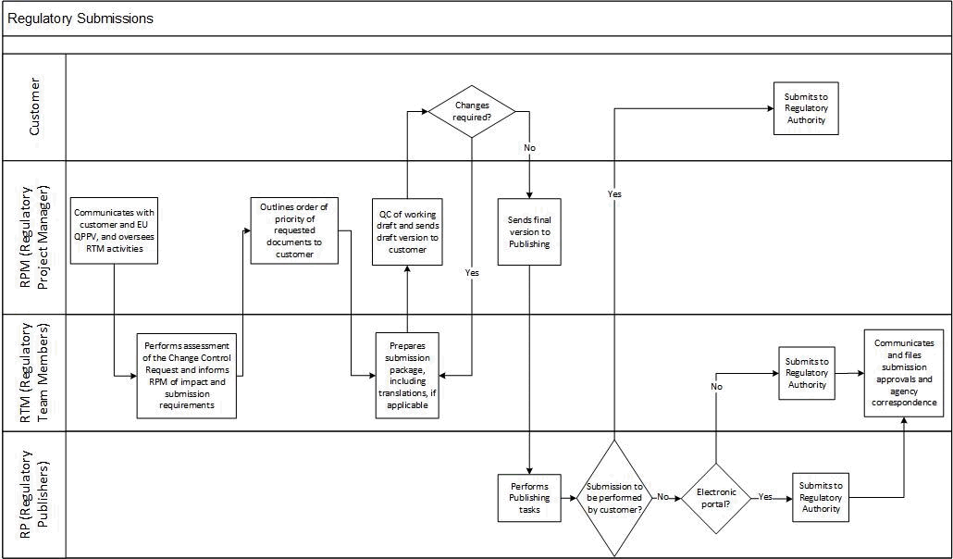

Appendix B: Tracking Log – Post Approval Changes

Procedure No. | Seq. No | Submission Type | Implementation Date | Planned Submission | Deadline for Submission (e.g. for 1A/1Ain) | Date of Submission | On Time (e.g. for 1A/1Ain) | Date Request for Information (RFI) Received (n/a if not  applicable) | RFI Response Date | Planned Approval | Date of approval | Date customer Informed of Approval | Comments

UserName: Lewicky, Tamara (q730348) Title:
Date: Monday, 04 October 2021, 08:57 AM Eastern Time Meaning: Signing this Document Indicates My Approval
================================================

UserName: Galea, Claudine (q769301) Title:
Date: Monday, 04 October 2021, 08:58 AM Eastern Time Meaning: Signing this Document Indicates My Approval
================================================

UserName: Kemp, Jaco (q608126) Title:
Date: Monday, 04 October 2021, 11:42 AM Eastern Time Meaning: Signing this Document Indicates My Approval
================================================

UserName: Rahman, Maggie (q1033930) Title:
Date: Monday, 04 October 2021, 11:48 AM Eastern Time Meaning: Signing this Document Indicates My Approval
================================================

UserName: Corley, Helen (q730385) Title:
Date: Monday, 04 October 2021, 12:38 PM Eastern Time Meaning: Signing this Document Indicates My Approval
================================================

UserName: Glizer, Veronica (q735279) Title:
Date: Wednesday, 06 October 2021, 12:57 PM Eastern Time Meaning: Signing this Document Indicates My Approval
================================================

UserName: Lobo, Zena (q833472) Title:
Date: Monday, 18 October 2021, 04:15 AM Eastern Time Meaning: Signing this Document Indicates My Approval
================================================

